Ex.No 8 Build the own private cloud using Eucalyptus

Aim
To Build the own private cloud using Eucalyptus.

Softwares Required
- faststart-3.4.1
- VMware workstation Pro

Eucalyptus
Eucalyptus is a Linux-based open-source software architecture for cloud computing and also a storage platform that implements Infrastructure a Service (IaaS). It provides quick and efficient computing services. Eucalyptus was designed to provide services compatible with Amazon’s EC2 cloud and Simple Storage Service (S3).
The Eucalyptus cloud platform primarily comprises of five main components, each briefly explained below:
Cloud controller (CLC): The cloud controller is essentially a Web-based interface between Eucalyptus and the outside world. It provides cloud administrators an interface with which they can configure and manage the cloud’s underlying compute, storage and network resources. It also handles high-level user authentication, quota management along with a few basic accounting and reporting mechanisms. Users can also query the CLC using Eucalyptus’s command line tools called Euca2ools.
Walrus: Walrus provides persistent storage capabilities to all of the virtual machines in the Eucalyptus cloud. It is basically a large storage container where users can upload data from any file type using simple HTTP put-get queries.
Cluster controller (CC): A typical Eucalyptus cloud set-up can comprise multiple nodes, which are actually hypervisors on which virtual machines are provisioned. These nodes can be collectively grouped and managed by using the cluster controller, which primarily looks after the inter-node communications and Service Level Agreements (SLAs) of each cluster.
Storage controller (SC): The storage controller provides persistent block-level storage for virtual machines that are launched within a Eucalyptus cloud. The SC interfaces with a wide variety of storage systems including local file systems, NFS, SAN and even iSCSI.
Node controller (NC): Node controllers or nodes are hypervisor-based virtualised servers that host virtual machines which are provisioned by the Eucalyptus cloud. Eucalyptus additionally provides an optional add-in component that even supports VMware ESXi hypervisor as a node, called a VMware broker.
Features
The latest release of Eucalyptus (Version 3.3.2) introduces many new features, some of which are explained below.
Auto-scaling: Mirrored on the concept of auto-scaling by AWS, Eucalyptus too provides similar APIs that help cloud administrators set rules and policies that enable applications running on virtual machines to scale-up and scale-down dynamically, based on fluctuating workloads.
Elastic load balancing: This is basically a service that provides better availability and scalability for applications running atop the Eucalyptus cloud. It automatically senses and distributes incoming application traffic and service calls across multiple running instances, thus improving the performance and uptime of the application.
CloudWatch: This provides monitoring for virtual machines and applications hosted on the Eucalyptus cloud. Using CloudWatch, users can programmatically track, collect and analyse metrics, set alarms to troubleshoot performance issues and take automated action as well, based on the state of the cloud environment.
Resource tagging: This allows users and cloud administrators to assign meaningful metadata to cloud resources. This helps in tracking, as well as eases management and monitoring of specific resource collections used across the cloud.
Maintenance mode: This feature enables cloud administrators to perform maintenance activities on the Eucalyptus cloud without any potential downtime. This helps make sure that the applications hosted on the cloud are always running and that they meet the required SLA levels as well.
Launching your first instance
To launch your first instance, all you need to do is follow these simple steps:
1) Create a security group: A security group is similar to a firewall that protects your instance against network-related attacks. By default, all inbound traffic to the instance is blocked.
Once your group is created, open the necessary ports such as SSH port 22 to obtain access to the instance.
2) Create a key pair: A key pair acts as an authentication token between the users and their instances.
3) Launch the instance: An instance is launched from a machine image (in this case, EMI). You will require an EMI ID to launch your first instance. This can be obtained from the Eucalyptus cloud user console.
The instance can take a couple of seconds to launch. You need to note down the instance IP address either from the terminal or by using the Eucalyptus cloud user console.

To install Cloud-in-a-Box:
- Boot the target system from the Eucalyptus Faststart media. Wait for the boot screen to load. When the boot screen loads, select "Install CentOS 6 with Eucalyptus Cloud-in-a-box"
- You may be asked to check the media, to ensure that there are no data issues. You may check the media, or you may Skip to move on to the next step. You will then be asked to select language and keyboard options. (Note that Faststart instructions are currently available in English only.)
- Next, you will be asked for network information. For Network Interface, select your ethernet interface (usually eth0). For Mode, Static is recommended; DHCP will work in many cases, but if DHCP leases change, your Eucalyptus cloud will no longer be functional. Also enter IP address, Netmask, Default Gateway, and a comma-delimited list of DNS servers.
- Next, you will be asked to select timezone, and after that you will be asked to enter the root password for the system.
- Next, you will be asked for cloud configuration options. Most are defaults that you should not touch unless you are an experienced Eucalyptus administrator; see the Administration Guide for details. The one parameter you must enter here is the range of public IP addresses. New virtual instances created by Eucalyptus will receive IP addresses from within this specified range. Enter the lower and higher range of available public IP addresses, a dash between them (e.g.: 192.168.1.200-192.168.1.240).
- Next, you will be asked for disk install options. Eucalyptus is intended to be the primary application on the system; by default, it will take up all disk space on the system. Experienced Linux admins can set up a separate partition for Eucalyptus here.
- At this point, the Eucalyptus installation will begin. Software will be installed, and a default Eucalyptus machine image (EMI) will be built. When this process is completed, you will be prompted to reboot the system.
- When the system reboots, you will be prompted for a series of questions during the firstboot process. You will be asked to accept the license, create a non-root login, and turn on NTP.

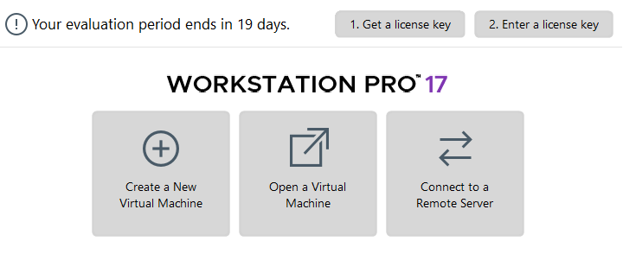
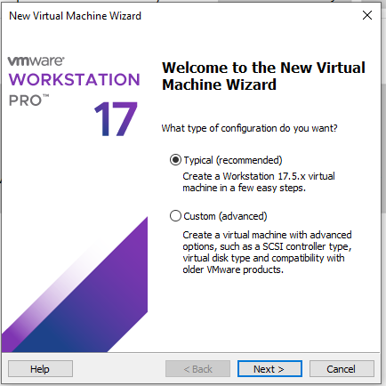

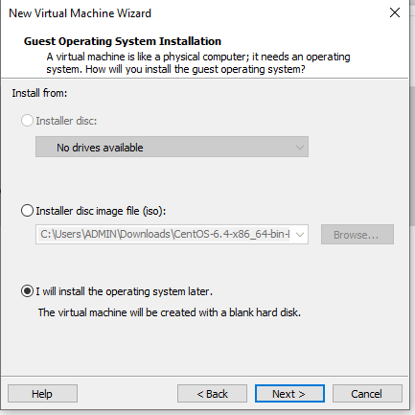

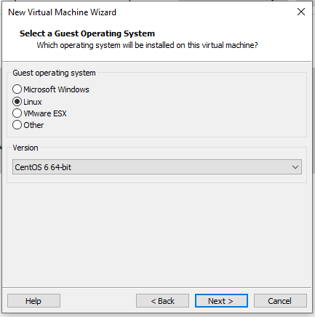

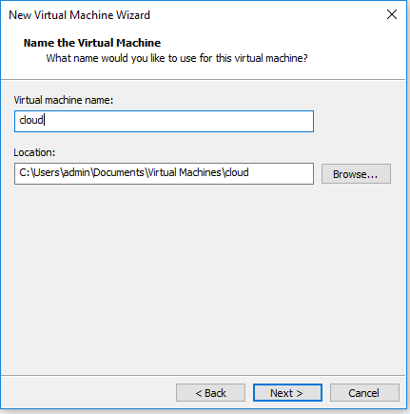

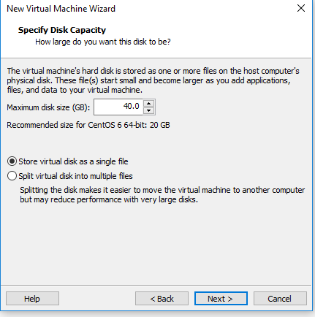

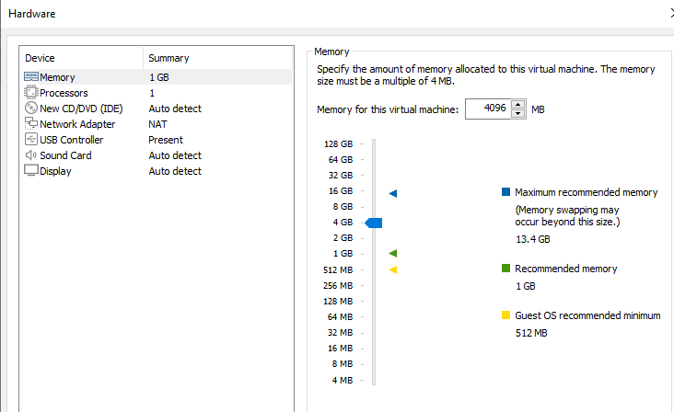

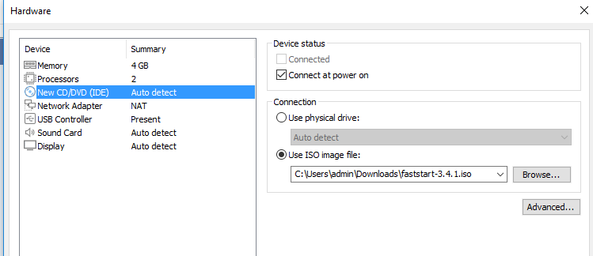

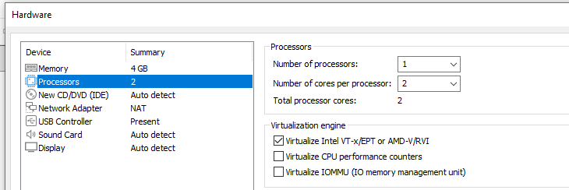

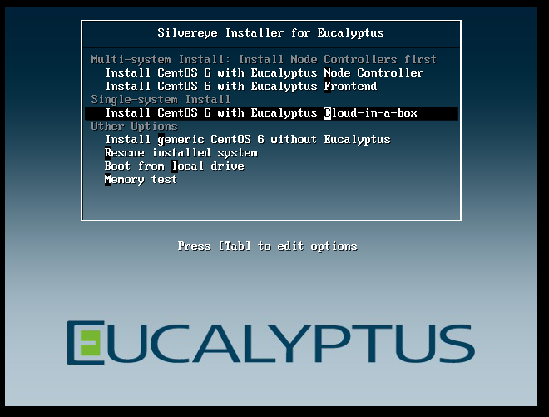

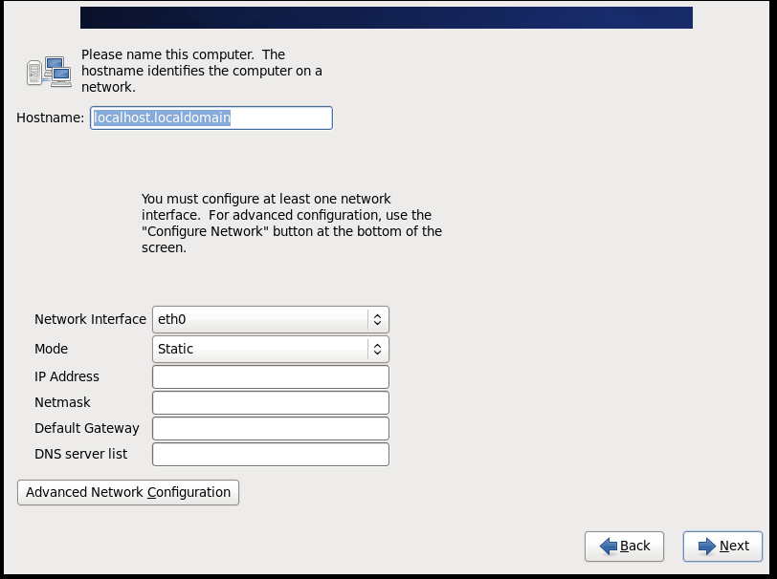
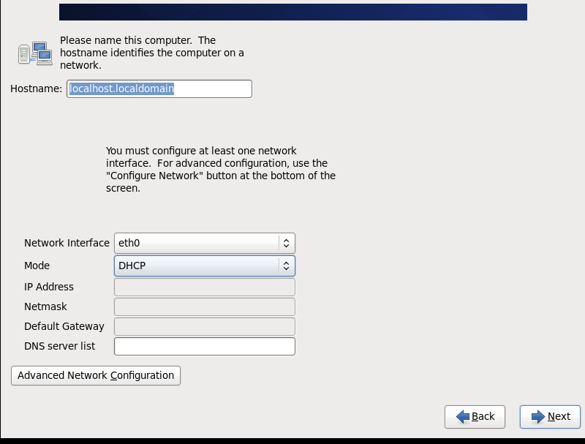

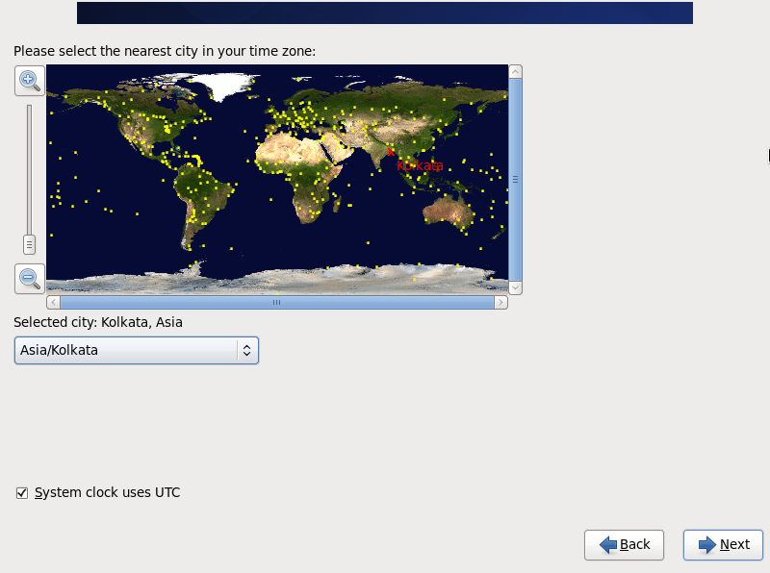

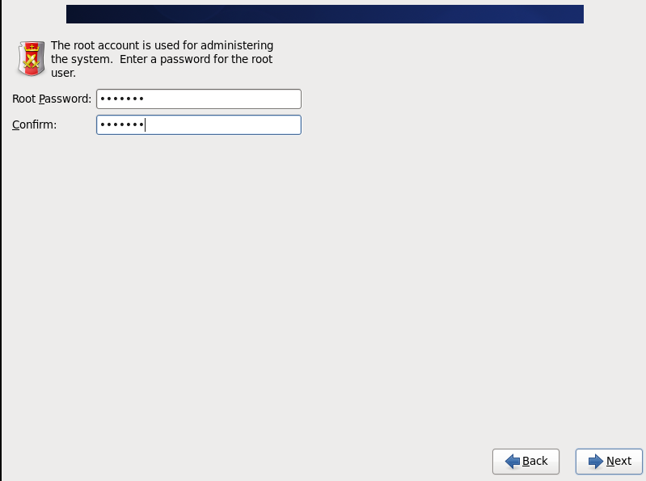

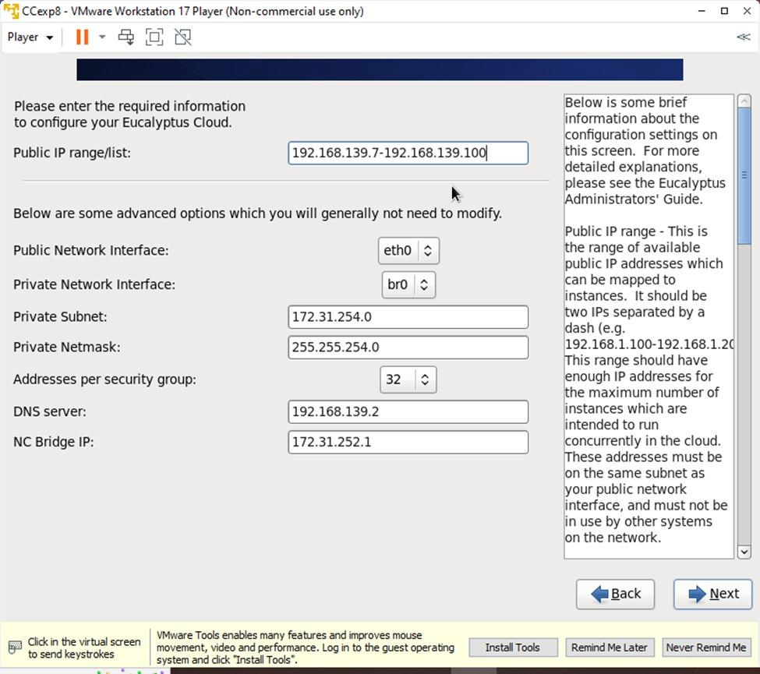

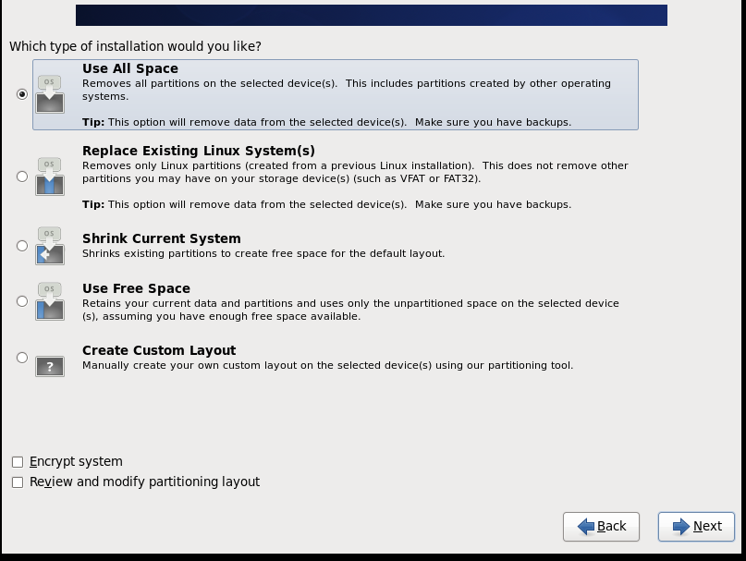
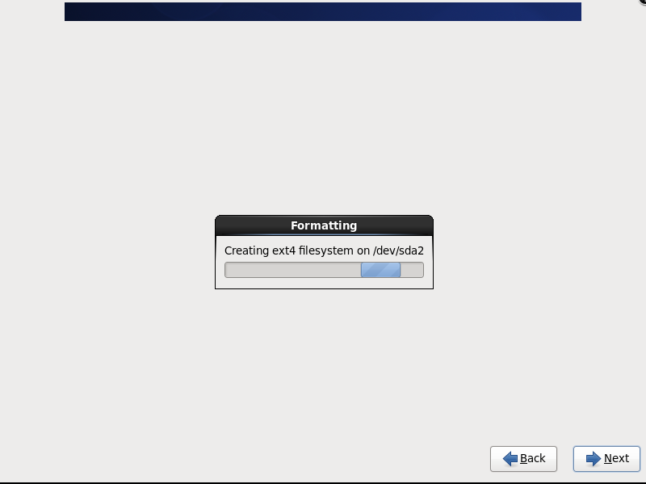
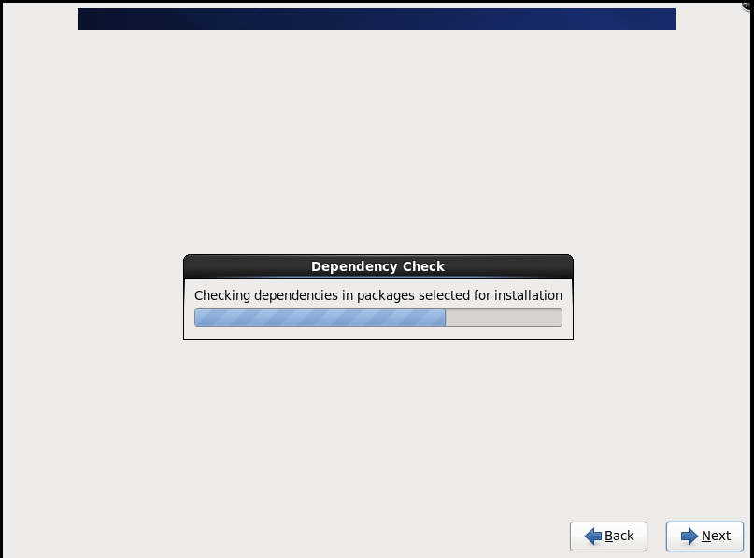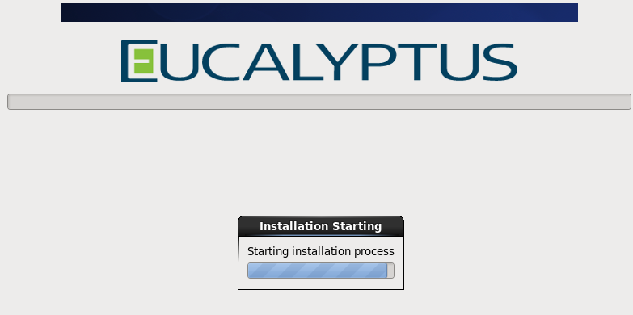

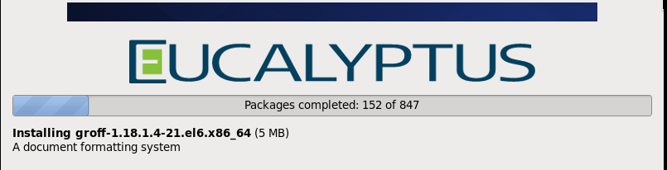
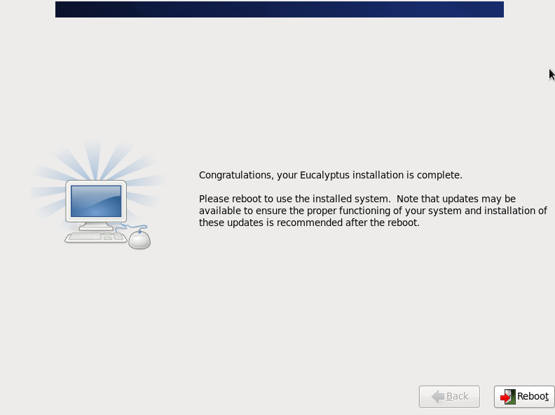

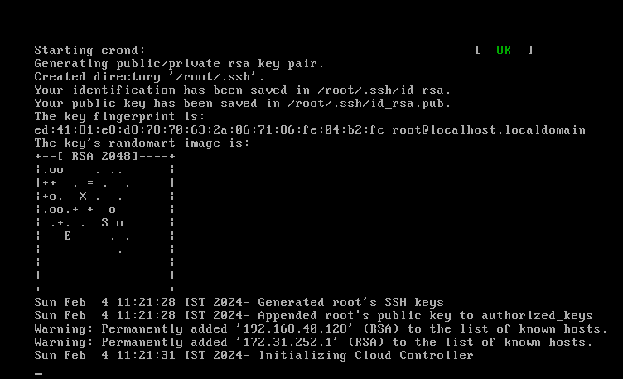

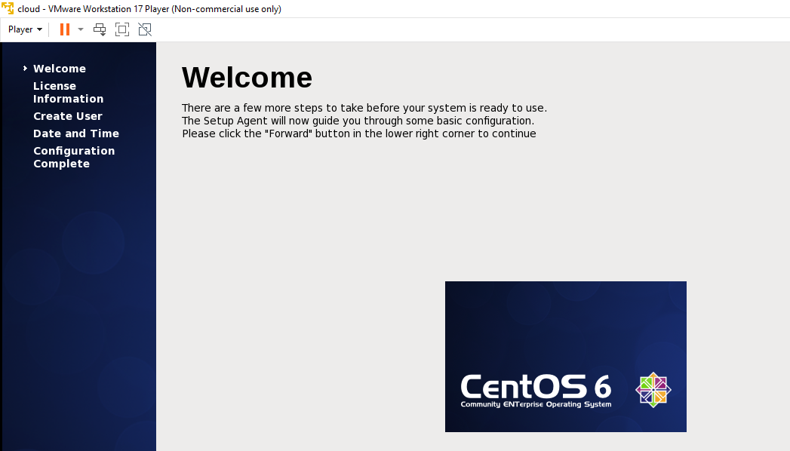
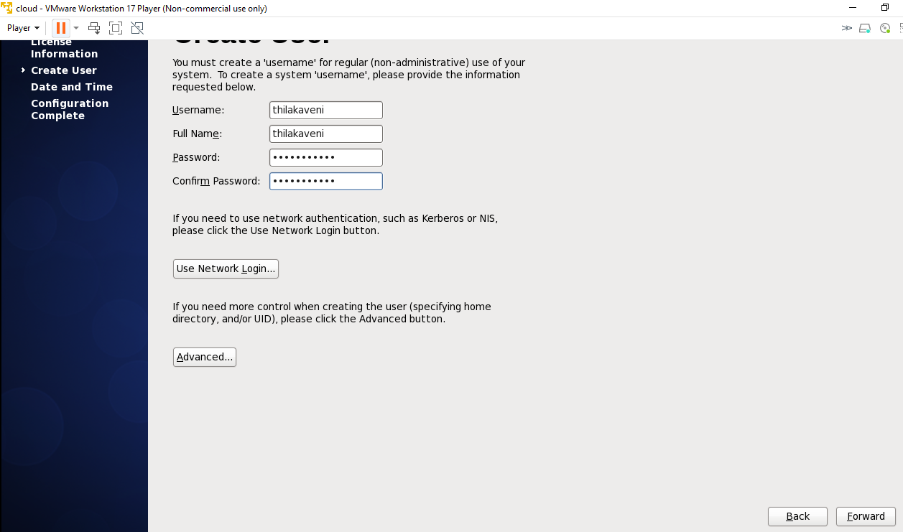

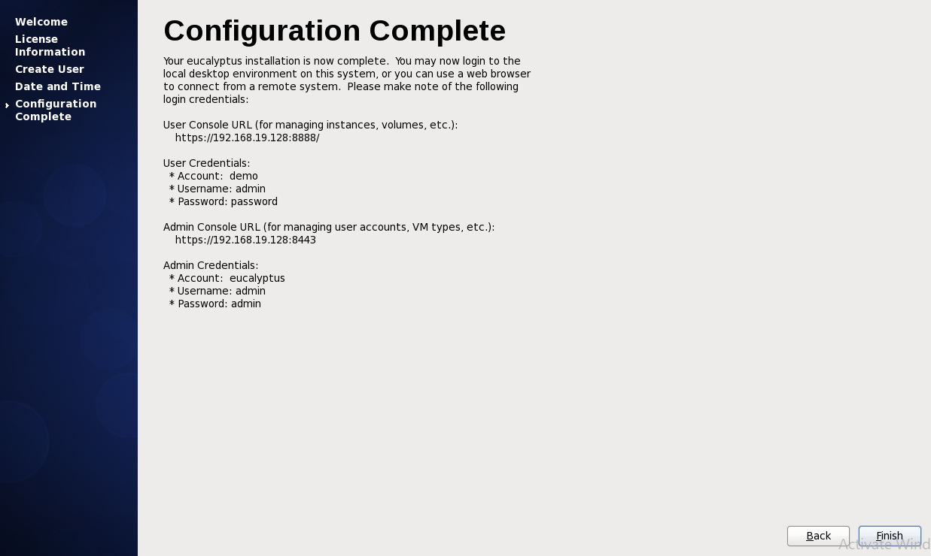

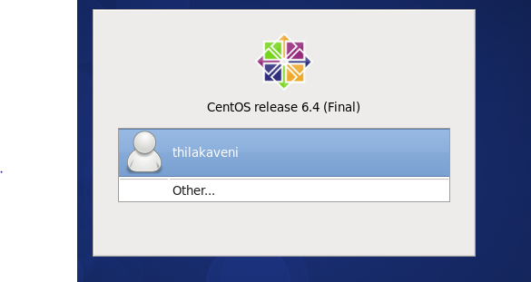

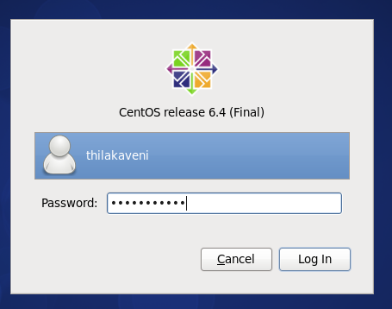

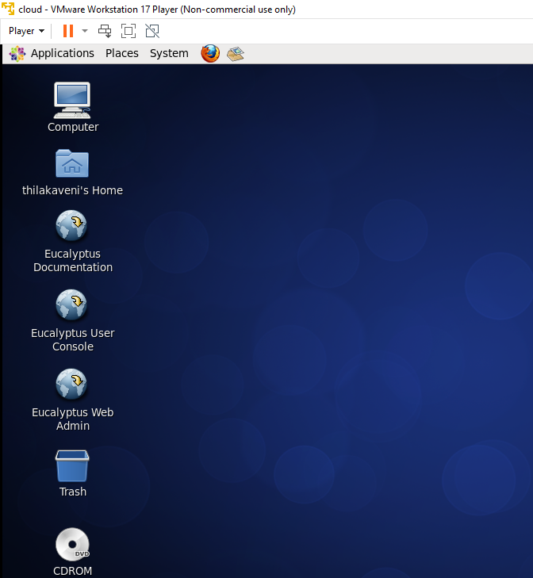

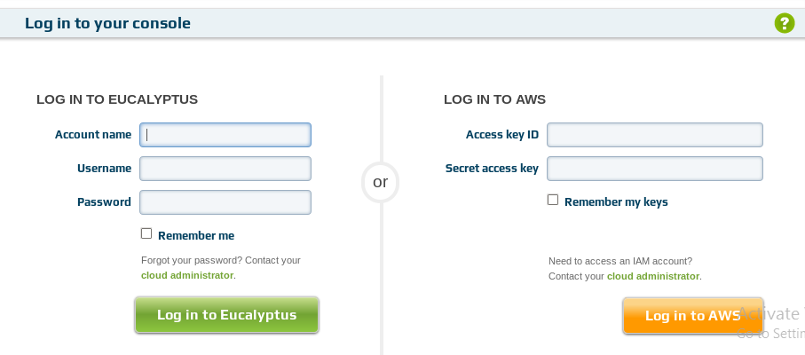

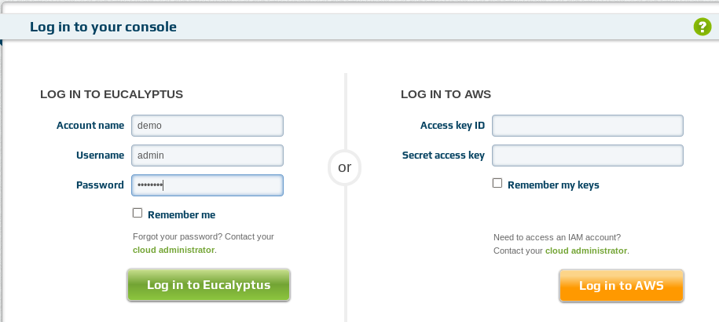

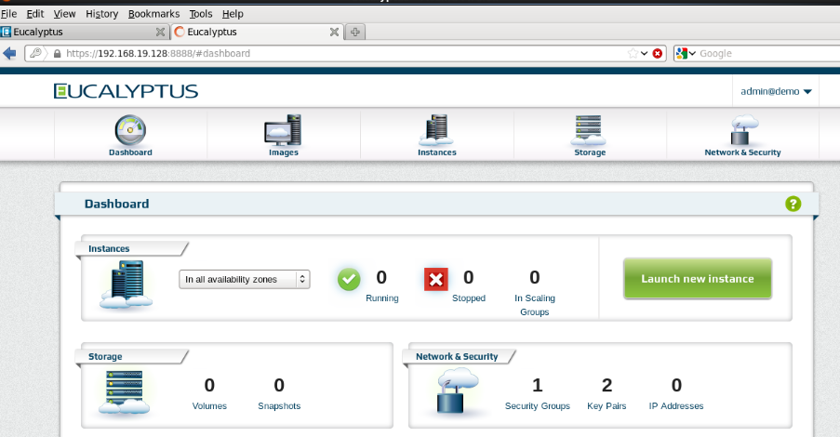

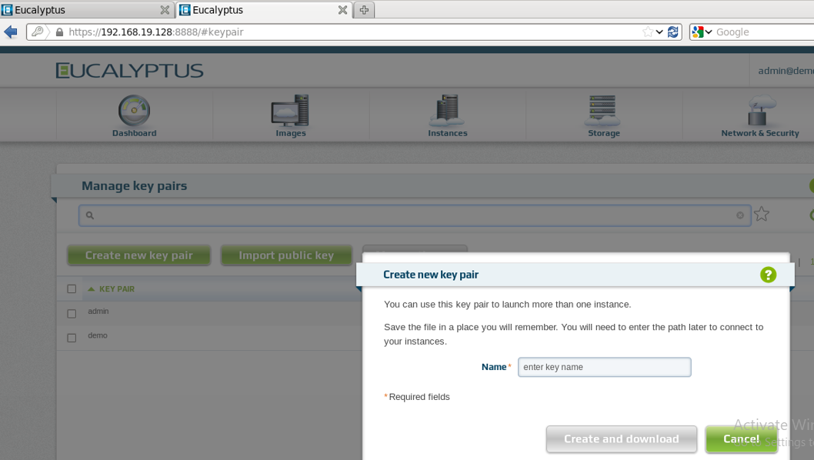

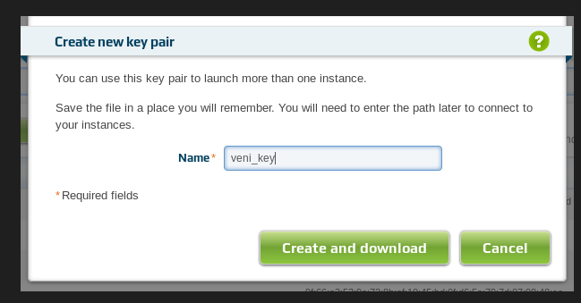
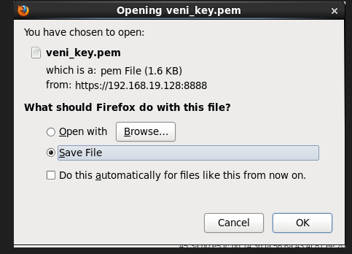

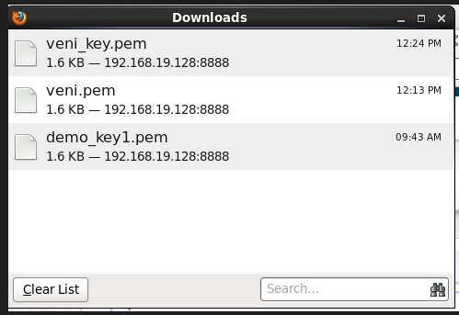

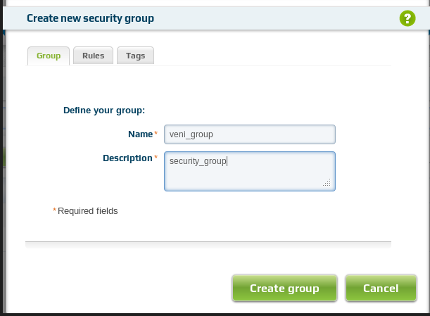
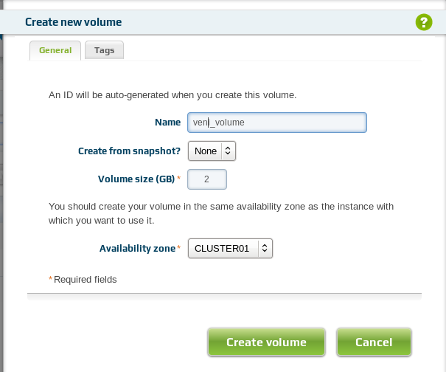
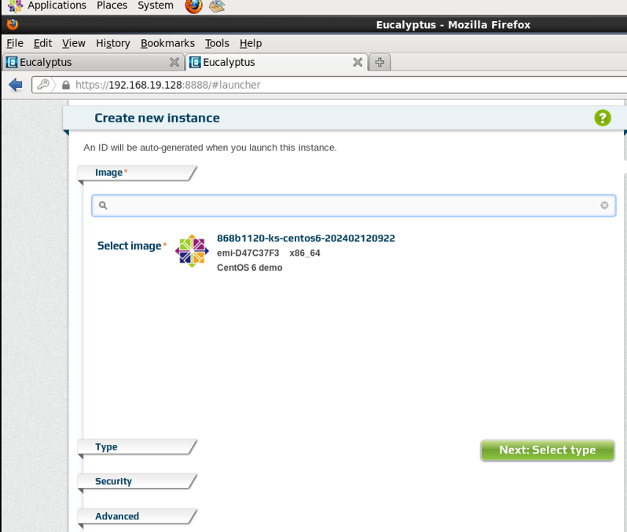

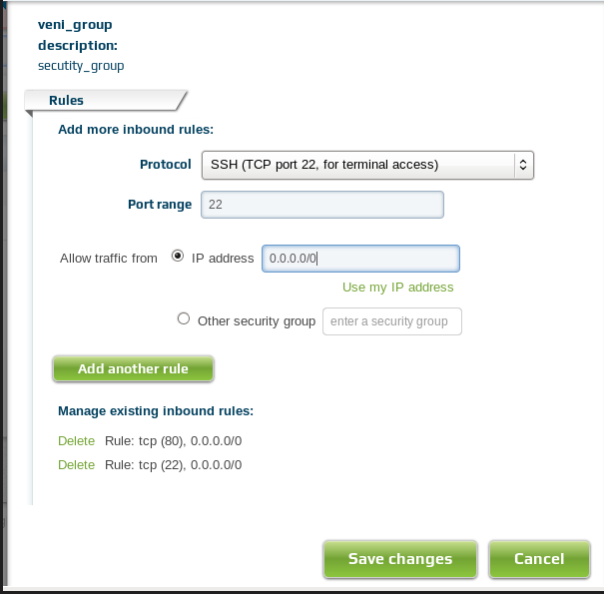

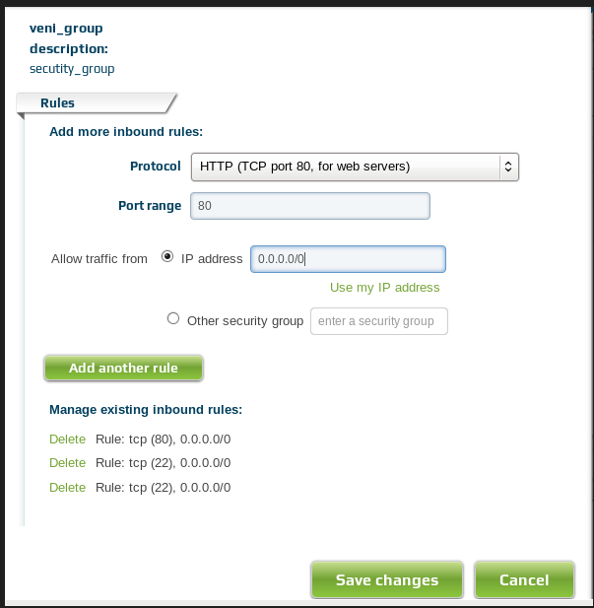

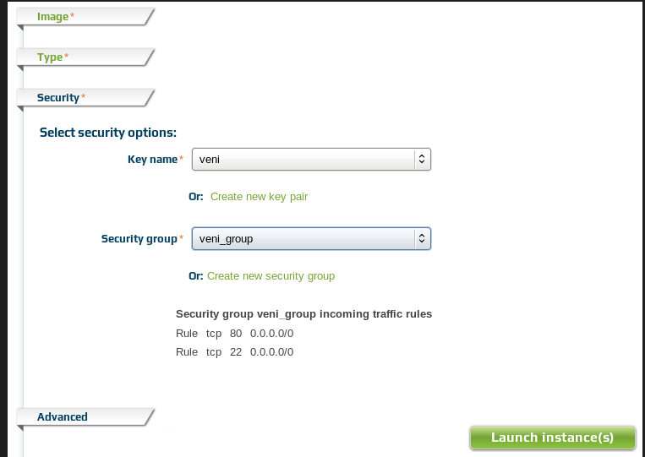

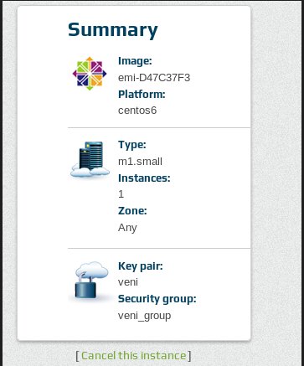

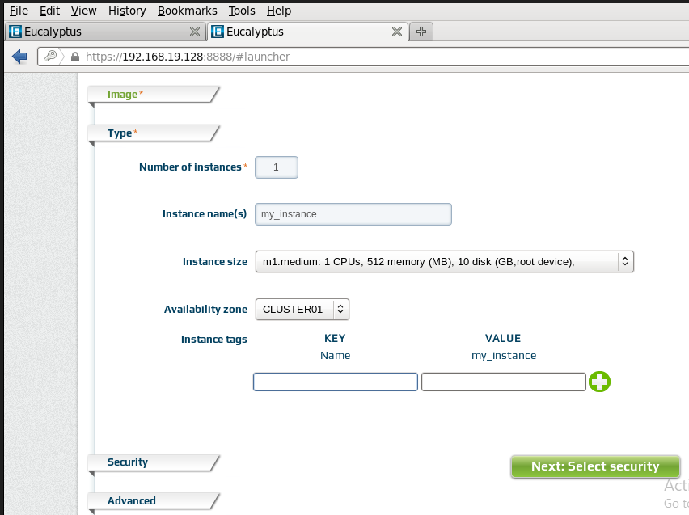

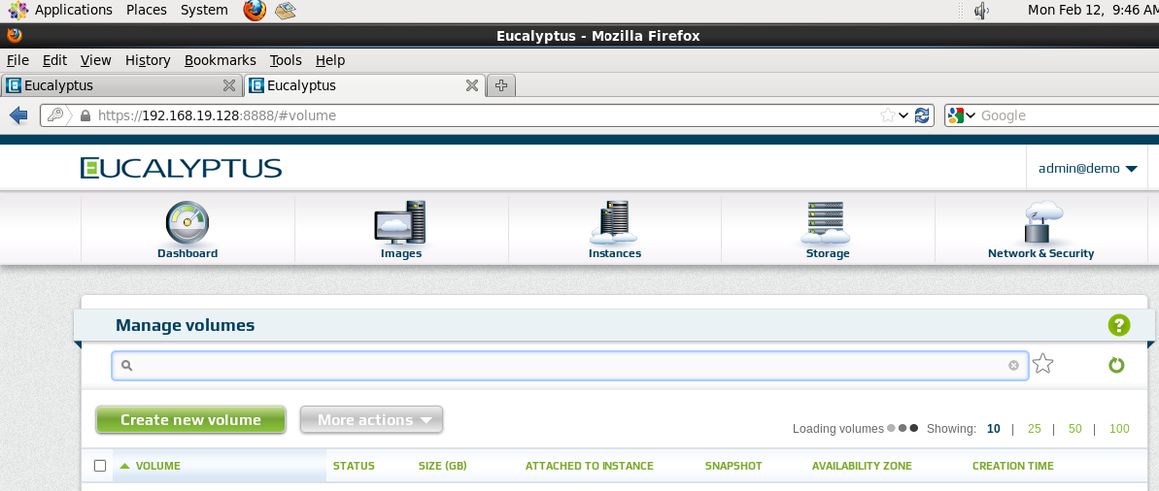

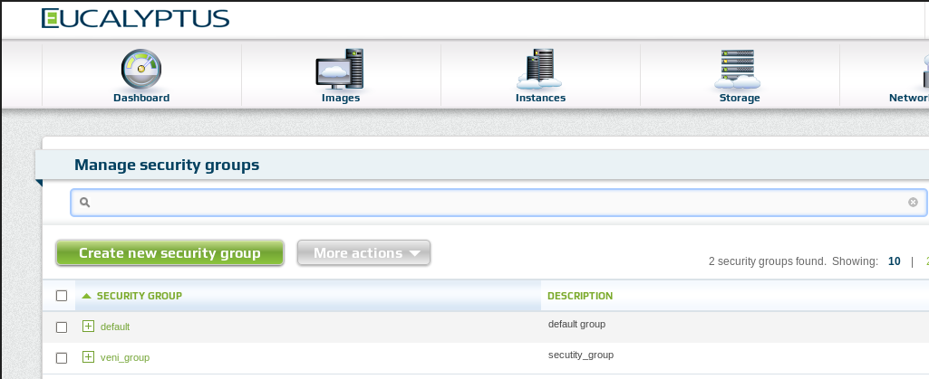

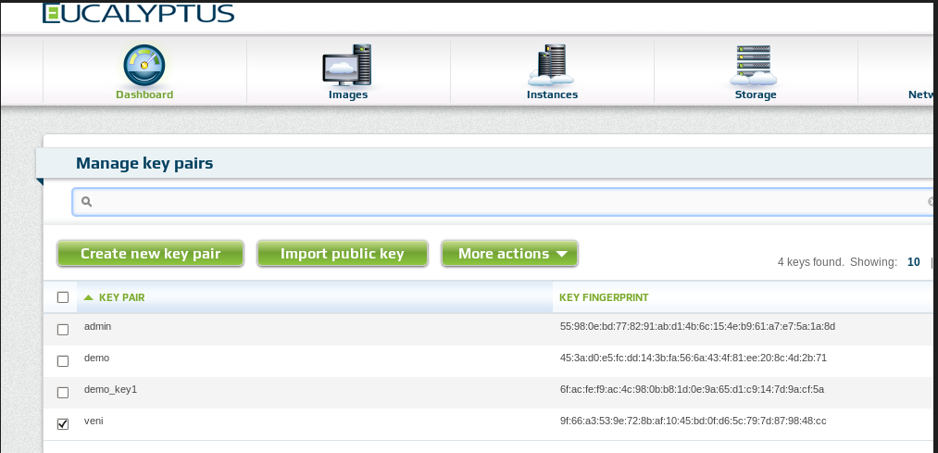

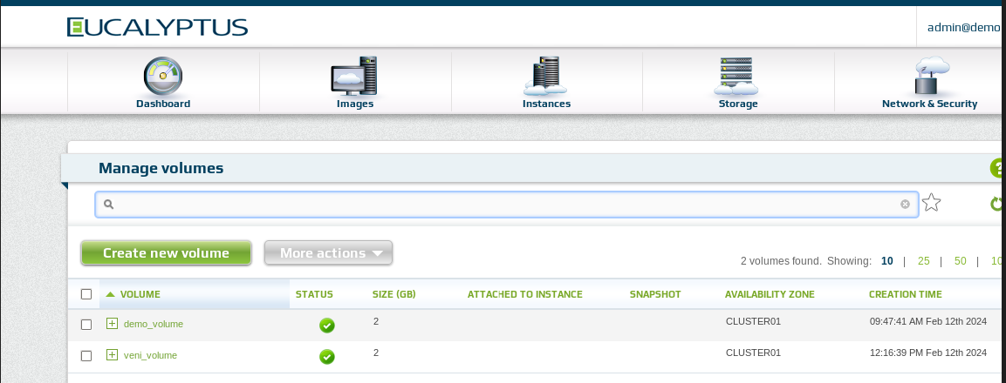

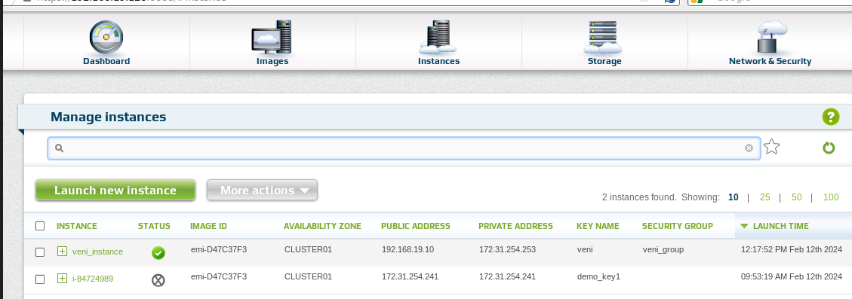

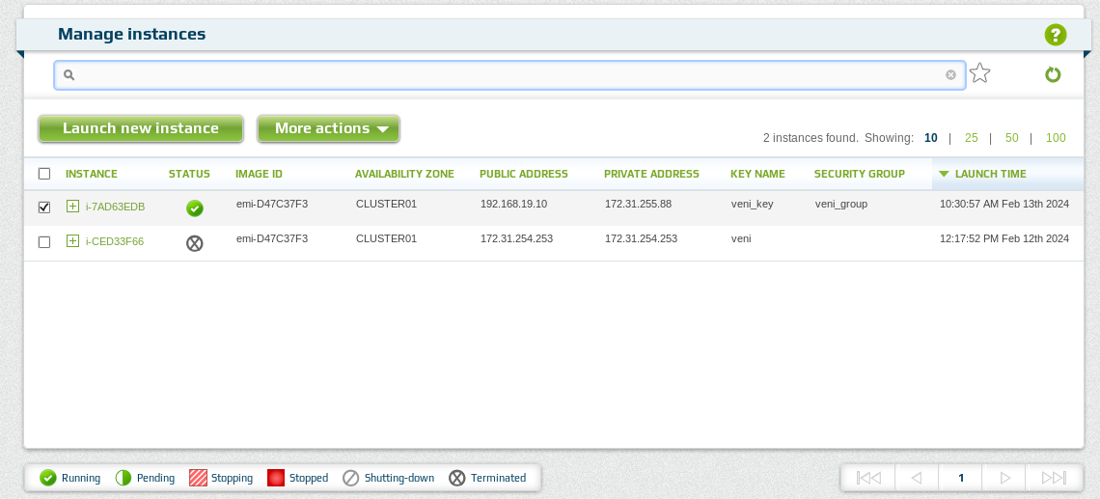

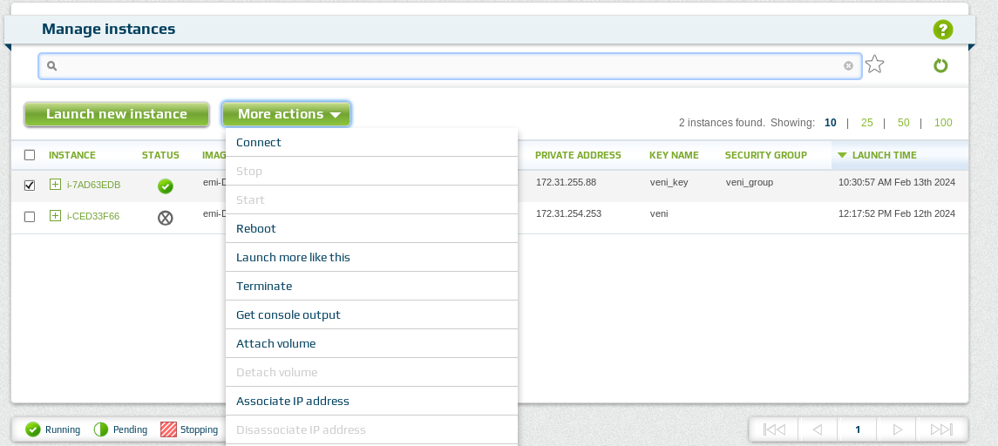

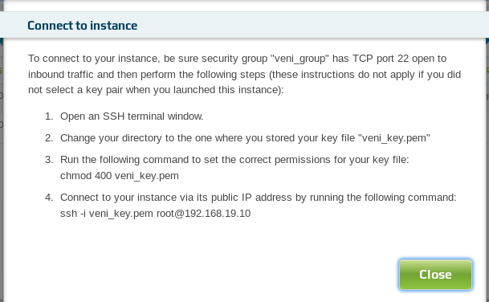

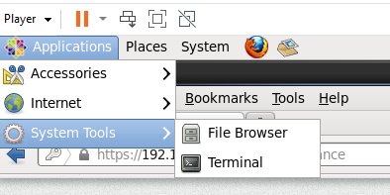

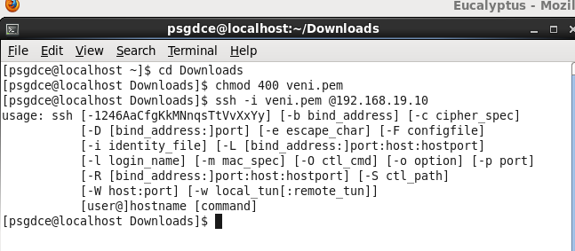

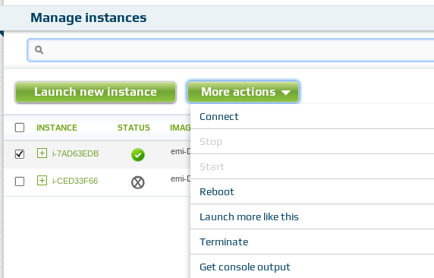

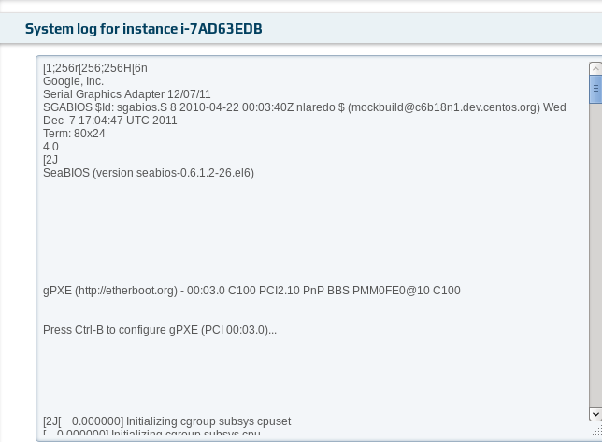

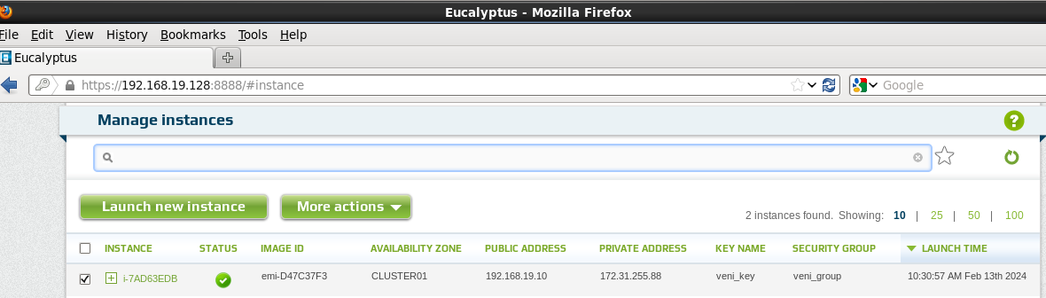

Result
Thus the eucalyptus private cloud was built and instance created.
Ex.No 9 Create an AWS account and activate

Aim
To create an AWS account and activate.
AWS
AWS (Amazon Web Services) is a comprehensive, evolving cloud computing platform provided by Amazon. It includes a mixture of infrastructure-as-a-service (IaaS), platform-as-a-service (PaaS) and packaged software-as-a-service (SaaS) offerings. AWS offers tools such as compute power, database storage and content delivery services.
AWS offers many different tools and products for enterprises and software developers in 245 countries and territories. Government agencies, education institutions, nonprofits and private organizations use AWS services.
Amazon Web Services offers a broad set of global cloud-based products including compute, storage, databases, analytics, networking, mobile, developer tools, management tools, IoT, security, and enterprise applications: on-demand, available in seconds, with pay-as-you-go pricing.
Steps to Creating a Free Tier AWS Account
Sign Up for an AWS Account
Step 1: Open https://portal.aws.amazon.com/billing/signup#/start/email in any browser, then enter your mail address and AWS account name. Click on “Verify Email Address”.
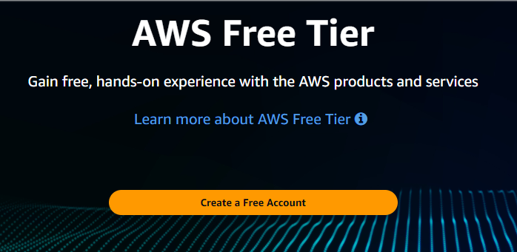

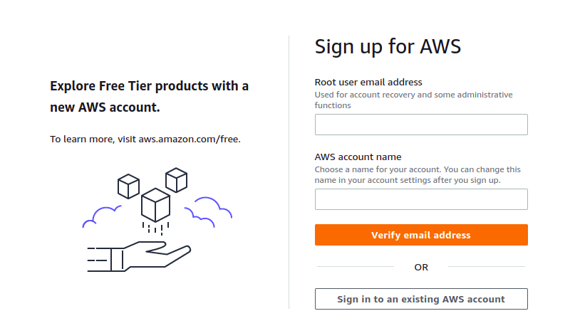

Step 2: Enter the verification code received in the email address entered and click on ‘Verify’.
Step 3: Enter the Root user Password and Confirm the Root user Password, then click on ‘Continue (step 1 of 5)’.
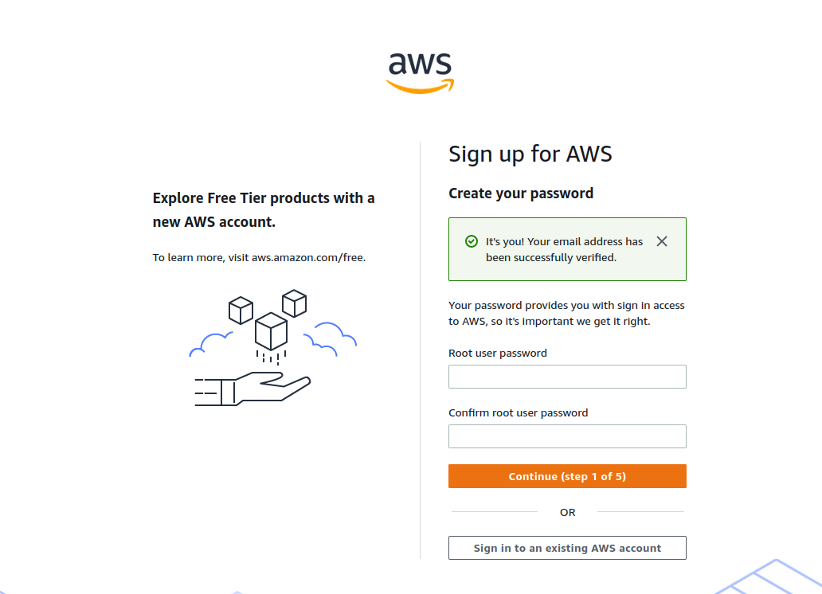

Step 4: Select ‘Personal – for your own projects’ and fill in the details including the full name, contact number, country or region, and address for communication, and then click on ‘Continue
(Step 2 of 5)’.
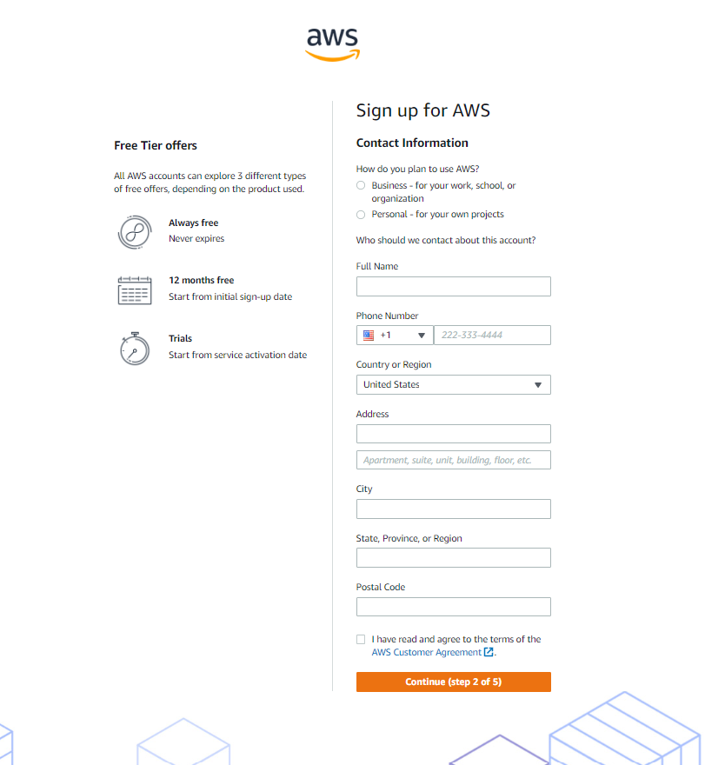

Step 5: Now in this step enter the Billing Information and then click on ‘Verify and Continue.
Step 6: Confirm your identity by entering your mobile number or email address. You will receive a verification code which you have to enter to confirm your identity.
Step 7: Select the support plan. For Free Tier, we have to select ‘Basic Support: Free’. Finally, the AWS account has been created and is ready for implementation.

Benefits of AWS Free Tier Account
- Hands-On Experience: Users can experience cloud services firsthand in a risk-free and realistic setting with the AWS Free Tier. This is very helpful for people who are just learning about AWS and cloud computing.
- Cost-Efficient Learning: New users can expose to new services of AWS without thinking about the cost
- Wide Range of Services: AWS offers wide range of services where a new user can explore different services can experience the real use of cloud computing.
- Scalability Testing: Users can test their applications by deploying it in AWS. They can test the application in different environments and in different conditions.
- Hosting Small Applications: Small applications can hosted on AWS for free as long as they adhere to the Free Tier usage restrictions.

Applications of AWS Free Tier Limit
Following are some of the applications of AWS free tier limit.
- Learning and Training: Students and the professionals who are new to AWS can learn using AWS free tier. Through practical experience with cloud services, it enables users to investigate and comprehend AWS services, infrastructure, and best practices.
- Development and Testing: Developers can use AWS free tier account to test their application in different environments without incurring cost.
- Startup and MVP Development: The AWS Free Tier is a useful tool for startups and entrepreneurs to create early-stage prototypes or minimal viable products (MVPs).
- Technical Certifications: The students who want to attend aws solution architect associate exam can use AWS free tier account fully fledged to prepare for the exam.
- AWS account creation
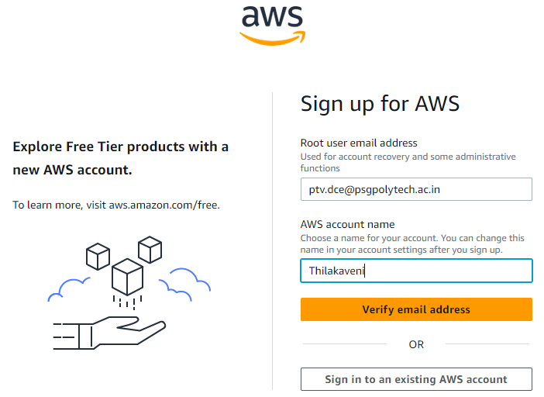
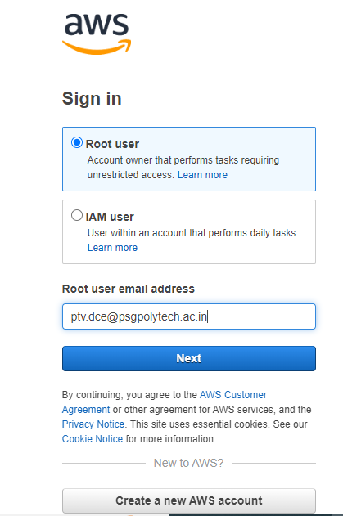
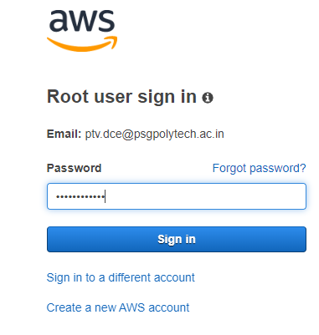
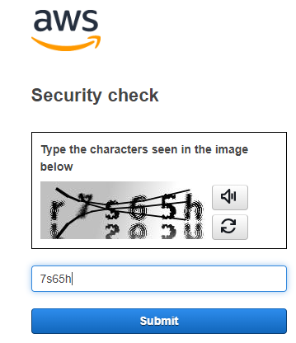
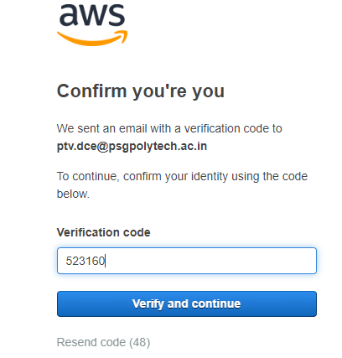
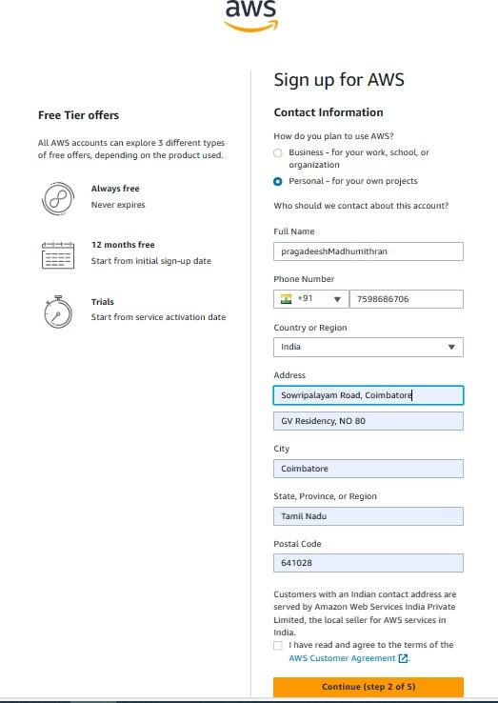

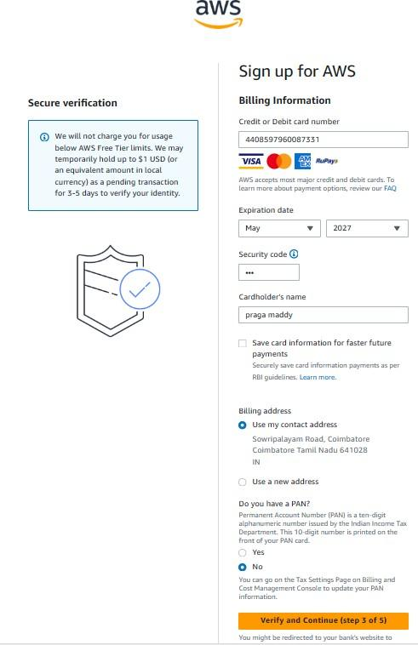

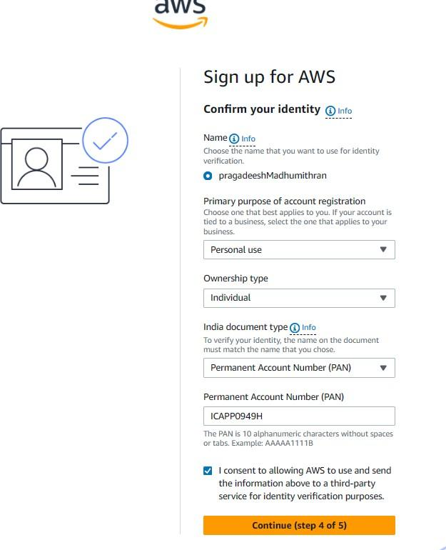

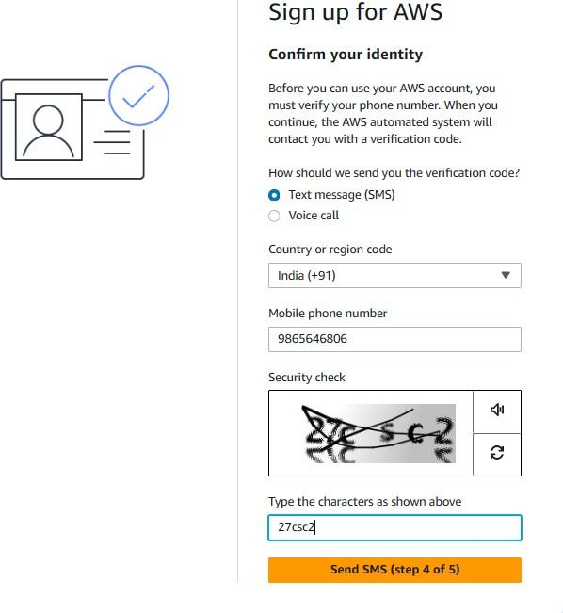

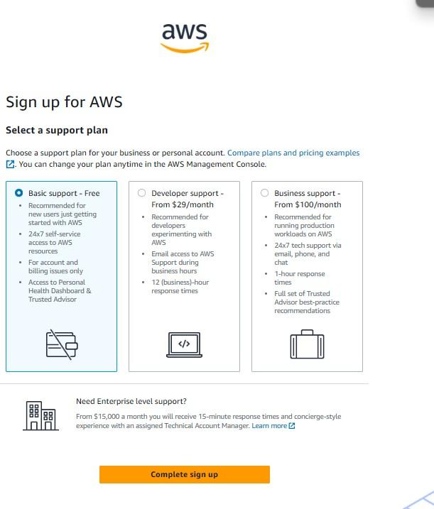

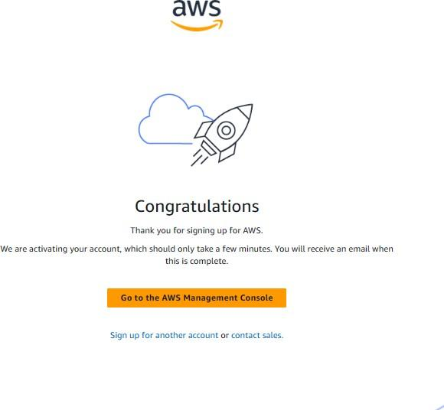
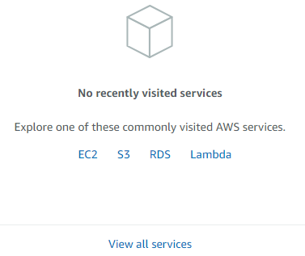
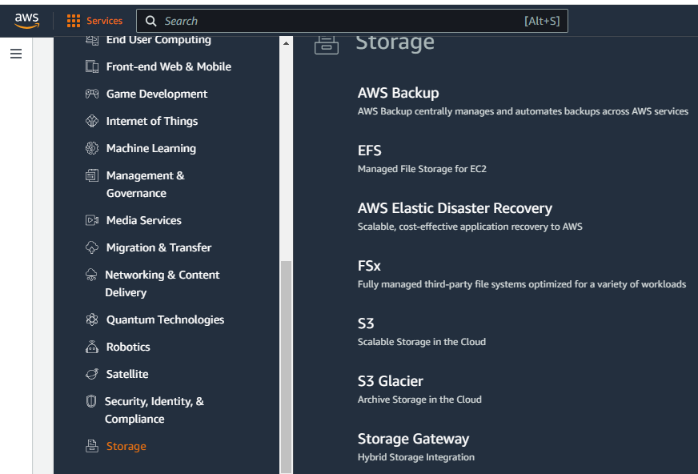

Result
Thus the AWS account was created and activated.

Ex.No 10 Install storage controller and interact with it

Aim
To install storage controller and interact with it.

Software Required
DiskGenius

A storage controller is a device that controls storage arrays, and mainly comprises the three types of components—"CPU" (central processing unit), "cache memory" and "connection interface with the network and memory devices." It is otherwise called "storage processor" or "array controller,"
Storage arrays all have some form of a processor embedded into a controller. As a result, a storage array’s controller is essentially a server that’s responsible for performing a range of functions for the storage system.

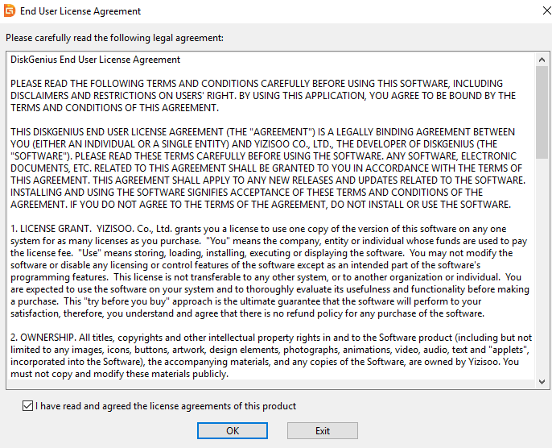
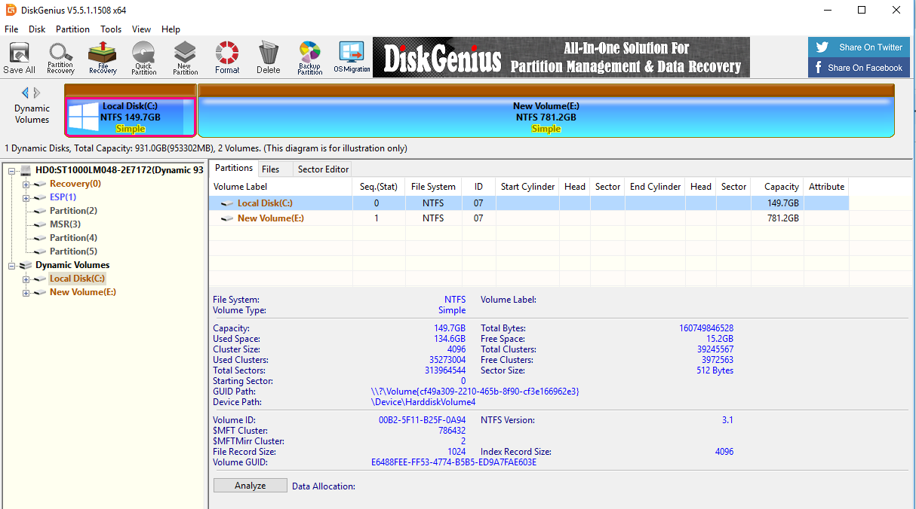
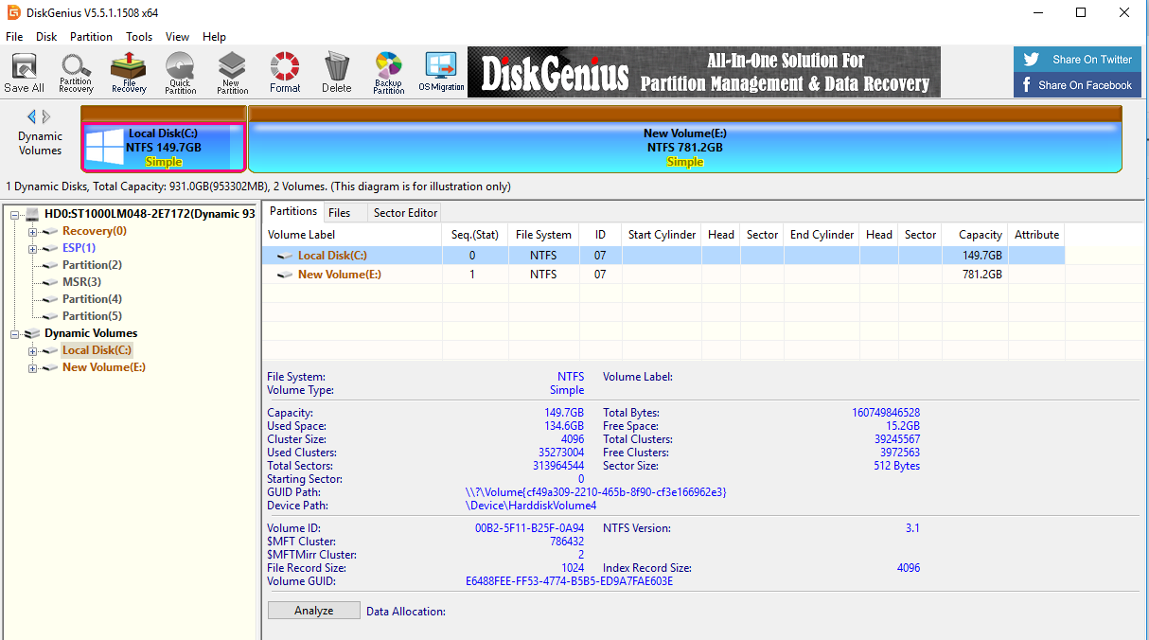
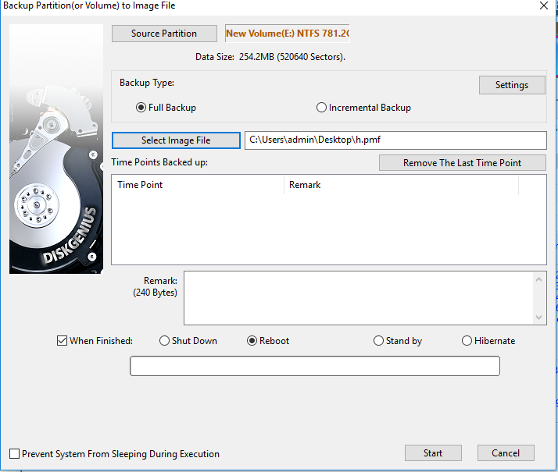
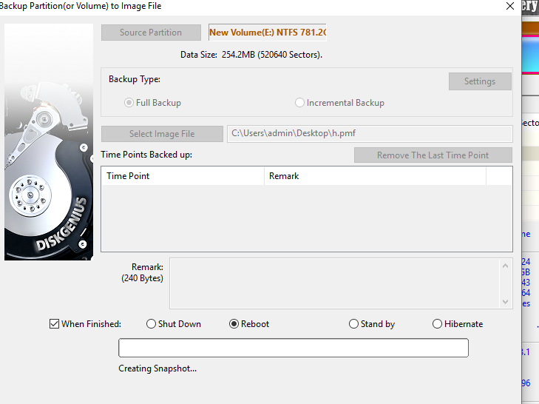

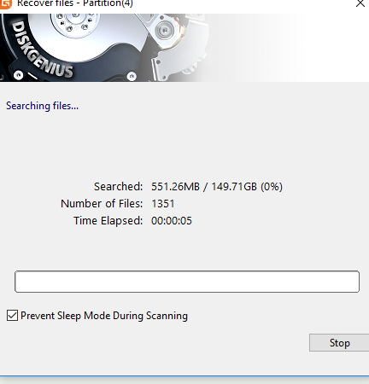
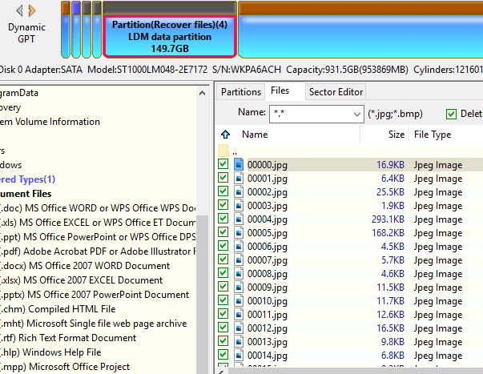

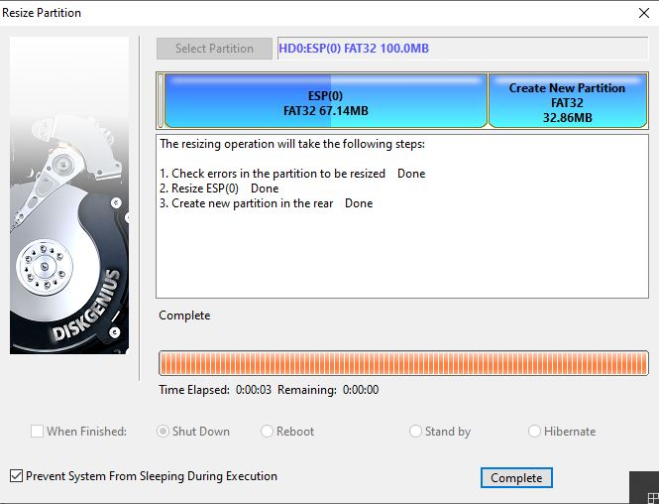
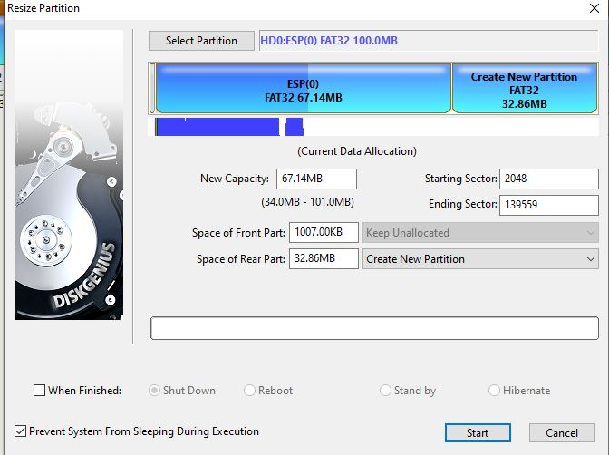

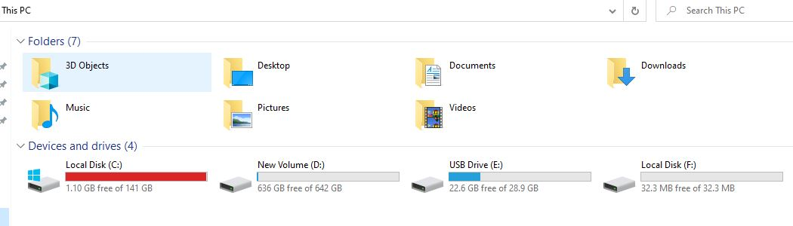

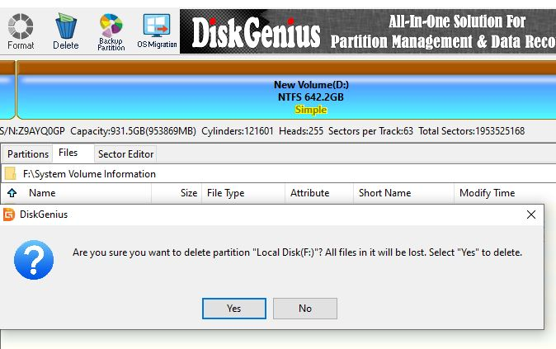

Result
Thus the storage controller was installed.

